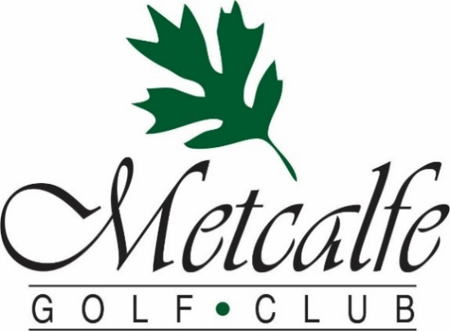

2021 Group Menu – Minimum 20 People
At Metcalfe golf the safety of our guests and staff is our number one priority.
We have developed COVID protocols that meet and/or exceed public health & government guidance which allow for your group to have an enjoyable and safe experience at the course. Buffets are not offered, but we have a variety of table service options and can also customize a menu to meet your needs.
We will work with you to ensure that our food, venue, and service create a day that you and your guests will enjoy and remember.
Hickories’ Summertime Fav’s
BBQ BURGERS - $16
Served with Fries & Coleslaw
3 Piece Country Fried Chicken - $18
Served with Fries & Coleslaw
Chef Tony’s Fall of the Bone Ribs - $21
½ Rack Served with Potato Wedges & Coleslaw
Chicken Caesar Wrap - $16
Grilled Chicken Breast with Romaine, Bacon & Our House Caesar Dressing.
Served with Fries
All Prices are subject to 13% gratuity and 13% HST
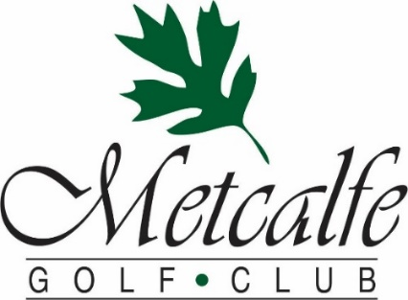
Hickories’ Gourmet Dinners
Chicken Supreme $24
Bacon wrapped Breast of Chicken topped with Honey Garlic Sauce
Served with Herb-Garlic roasted potato and fresh vegetables
8 Ounce New York Striploin - $28
Served with Herb-Garlic Roasted Potato Fresh Seasonal Vegetables
Hickories Salmon Filet - $25
Baby Shrimp and Lemon-Dill Hollandaise Sauce
Served with Herb-Garlic Roasted Potato Fresh Seasonal Vegetables
Stuffed Chicken Gorgonzola $24
Chicken Breast stuffed with Spinach, Mushroom and Asiago Cheese
topped with Gorgonzola Cream Sauce. Served with Rice and Fresh Seasonal Vegetables
Make Your Meal 2 or 3 Course Dinner
Salad Options
Side Caesar Salad - $5
Side Garden Greens - $4
Add a Dessert
Desert Squares - $2
Chocolate Truffle Royal, Carrot Cake or New York Cherry Cheesecake $4
All Prices are subject to 13% gratuity and 13% HST

