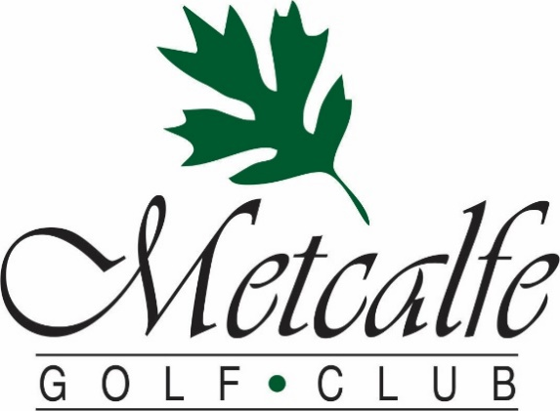

2022 Tournament Rates & Packages
We will work with you to ensure that our food, venue, and service create a day that you and your guests will enjoy and remember.
Here are some of the benefits that Metcalfe Golf offers to tournament organizers:
- Experienced management and staff to help every step of the way
- Amazing meals created by our professional Chef
- Two scenic & beautiful golf courses to choose from
- Ability to use our online store to handle registration and payment
- Advice and set up for fun on course contests
- Assistance with fundraising ideas
- Our commitment to help you every step of the way
Start Formats:
Tee Times:
- Tee times reduce the time commitment your players are making, they arrive for their tee off, experience a faster pace of play, and may leave right after golf or their meal.
- Provides the organizer more time to connect with each group before and after golf.
- Approximately 28 people may be accommodated each hour, meaning a group of 72 will take about 2.5 hours to start.
- Are available for any size group, any day of the week with any package.
Shotgun Starts:
- Allow the entire group to start at the same time and all players will finish within a 1-hour period, allowing for everyone to dine at the same time.
- Are offered on a limited number of days through the golf season.
- Require a minimum spend on green fees, carts, food, or merchandise of $8000 before tax for an 18-hole course shotgun or $4000 before tax for a 9-hole course shotgun.

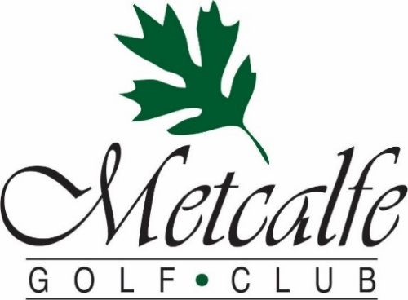

2022 Tournament Rates (Subject to HST)
2022 Regular Green Fee Rates
18 Holes: $53 or with Cart $72.47 9 Holes: $31 or with Cart $41.62
2022 Tournament Rates
18 Holes: $45 or with Cart $62 9 Holes: $26 or with Cart $35
2022 Tournament Package Discounts
- Add $17-$25 per person in Food & Beverage and receive $3 off the above rates
- Add $26–$34 per person in Food & Beverage and receive $5 off the above rates
- Add $35+ per person in Food & Beverage and receive $8 off the above rates
Here are some of our most popular packages:
Golf, Cart & BBQ Burger/Grilled Chicken Buffet 18 Holes $83 9 Holes $56
Golf, Cart, Chicken & Pasta Buffet 18 Holes $91 9 Holes $64
Golf, Cart & Roast Beef Buffet 18 Holes $96 9 Holes $69
Golf, Cart & Steak Dinner Buffet 18 Holes $101 9 Holes $75
All Package Prices include gratuity but are subject to 13% HST
Add a Custom Golf Gift to your packages
- Golf Balls starting at $6 per sleeve
- Hats, Towels, Water Bottles, and other gifts starting at $9
- Golf shirts and clothing starting at $25

Classic Tournament Buffets

Hickories Famous Roast Beef Buffet
Slow-roasted AAA Roast Beef
Marinated in our special blend of spices with Red Wine “au Jus”
Penne Pasta in Sun-dried Tomato “Rose” Sauce
Crisp Mixed Greens & Fresh Garden Vegetables with an assortment of Dressings
Creamy Citrus Summer Coleslaw
Chef’s Seasonal Salad Selection
Seafood Pasta Salad (with minimum of 40 guests)
Roasted Garlic and Rosemary Potatoes
Steamed Seasonal Vegetables
Fresh Baked Rolls
Fantastic Assorted Dessert Table
Coffee, Tea
$37

From the Fields

Marinated AAA 10oz Striploin Steak grilled to your liking right off our BBQ
Herb Roasted Medley of Bermuda Onions, Sweet Bell Peppers & Local Mushrooms
Slow-baked PEI Potatoes with all the fixings
Crisp Mixed Greens & Fresh Garden Vegetables with an assortment of Dressings
Creamy Citrus Summer Coleslaw
Chef’s Seasonal Salad Selection
Fresh Baked Rolls
Fantastic Assorted Dessert Table
Coffee, Tea
$42

All Prices Are Per Person - 13% HST & 13% Gratuity are not included

Hickories Garlic Chicken & Pasta Dinner

Char-grilled Chicken s/w Our House Garlic Dipping Sauce
Penne Pasta in Pesto cream Sauce
Crisp Mixed Greens & Fresh Garden Vegetables with an assortment of Dressings
Creamy Citrus Summer Coleslaw
2 of our Chef’s Seasonal Salad Selection
Herb-Garlic Roasted Potatoes
Steamed Seasonal Vegetables
Fresh Baked Rolls
Fantastic Assorted Dessert Table
Coffee, Tea
$30

Hickories Backyard BBQ

Perfect for Lunch or a Light Dinner
The Grill: Choice of Our House Marinated Chicken Breast or Angus Beef Pattie
Assorted Condiments & Toppings
Specially Seasoned Kettle Potato Chips
Crisp Mixed Greens & Fresh Garden Vegetables with an array of Dressings
Creamy Citrus Summer Coleslaw
The Chef’s Season Salad Selection
Assorted Dessert Squares
Coffee, Tea
$21

All Prices Are Per Person - 13% HST & 13% Gratuity are not included

Popular Pre-Tournament Lunch Options

Pre-Game Grill to Go Option #1
Choice of Grilled Angus Burger or Italian Sausage
$6
Pre-Game Grill to Go Option #2
Choice of Grilled Angus Burger or Italian Sausage
Choice of Non-Alcoholic Beverage & Chips
$10
Pre-Game Grill to Go Option #3
Choice of Grilled Angus Burger or Italian Sausage
Choice of Domestic Tall Boy & Chips
$14
Boxed Lunch
Turkey, Ham & Cheese Wrap with Lettuce and Tomato
Kettle Chips & Bottle of Water
$13.00
BURGER BBQ
Assorted Condiments & Toppings
Specially Seasoned Kettle Potato Chips
Crisp Mixed Greens & Fresh Garden Vegetables with an assortment of Dressings
Creamy Citrus Summer Coleslaw
$17
Ask us about a custom menu or these other great tournament favourites
Continental or Full Breakfasts
On Course Food & Drink Stations
Post golf-appetizers
All Prices Are Per Person - 13% HST & 13% Gratuity are not included

Hickories 3 Course Table Service Meals

Soup or Salad Choice Of:
Mixed Greens & Crisp Vegetables with our House Garlic Dressing
(upgrade to Caesar Salad for $3)
or
Our Chef’s Soup Creation
Entrees Choice Of:
Char-grilled 8oz Alberta AAA Striploin
(upgrade to 10oz $4)
Herb-Garlic Roasted Potato & Seasonal Vegetables
or
Roasted Red Pepper and Goat Cheese Stuffed Chicken
7oz Stuffed chicken supreme with light cream thyme sauce
Herb-Garlic Roasted Potato & Seasonal Vegetables
or
Hickories Atlantic Salmon Filet
Topped with Baby Shrimp & Creamy White Wine-Dill Sauce
Herb-Garlic Roasted Potato & Seasonal Vegetables
Dessert Choice Of:
Rich Chocolate Fudge Cake with Raspberry Coulis
or
Old Fashioned Carrot Cake with Cream Cheese Icing
or
Decadent Pecan Pie with Maple Caramel Sauce

$39

Table Service Meals for groups of 15 or more
1 Soup or Salad, 1 Entrée & 1 Dessert must be chosen for the entire group

All Prices Are Per Person - 13% HST & 13% Gratuity are not included

