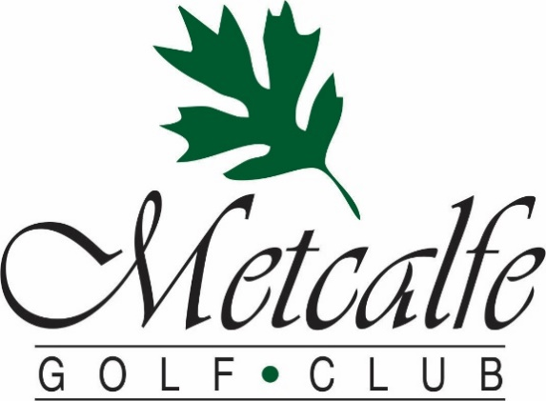

2023 Tournament Rates & Packages
We will work with you to ensure that our food, venue, and service create a day that you and your guests will enjoy and remember.
Here are some of the benefits that Metcalfe Golf offers to tournament organizers:
- Experienced management and staff to help every step of the way
- Amazing meals created by our professional Chef
- Two scenic & beautiful golf courses to choose from
- Ability to use our online store to handle registration and payment
- Advice and set up for fun on course contests
- Assistance with fundraising ideas
- Our commitment to help you every step of the way
Start Formats:
Tee Times:
- Tee times reduce the time commitment your players are making, they arrive for their tee off, experience a faster pace of play, and may leave right after golf or their meal.
- Provides the organizer more time to connect with each group before and after golf.
- Approximately 28 people may be accommodated each hour, meaning a group of 72 will take about 2.5 hours to start.
- Are available for any size group, any day of the week with any package.
Shotgun Starts:
- Allow the entire group to start at the same time and all players will finish within a 1-hour period, allowing for everyone to dine at the same time.
- Are offered on a limited number of days through the golf season.
- Require a minimum spend on green fees, carts, food, or merchandise of $9000 before tax for an 18-hole course shotgun or $3500 before tax for a 9-hole course shotgun.

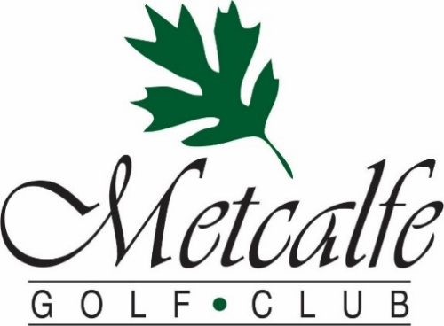

2023 Tournament Rates (Subject to HST)
2023 Regular Green Fee Rates
18 Holes: $57 or with Cart $77.80 9 Holes: $33 or with Cart $44.50
2023 Tournament Rates
18 Holes: $48 or with Cart $67 9 Holes: $28 or with Cart $38
2023 Tournament Package Discounts
- Add $19-29 per person in Food & Beverage and receive $3.50 off the above rates
- Add $30-39 per person in Food & Beverage and receive $6 off the above rates
- Add $40+ per person in Food & Beverage and receive $9 off the above rates
Here are some of our most popular packages:
Golf, Cart & BBQ Burger/Grilled Chicken Buffet 18 Holes $92 9 Holes $66
Golf, Cart, Chicken & Pasta Buffet 18 Holes $99 9 Holes $70
Golf, Cart & Roast Beef Buffet 18 Holes $105 9 Holes $76
Golf, Cart & Steak Dinner Buffet 18 Holes $111 9 Holes $82
All Package Prices include gratuity but are subject to 13% HST
Add a Custom Golf Gift to your packages
- Golf Balls starting at $6 per sleeve
- Hats, Towels, Water Bottles, and other gifts starting at $9
- Golf shirts and clothing starting at $25

Classic Tournament Buffets

Hickories Famous Roast Beef Buffet
Slow-roasted AAA Roast Beef
Marinated in our special blend of spices with Red Wine “au Jus”
Penne Pasta in Sun-dried Tomato “Rose” Sauce
Crisp Mixed Greens & Fresh Garden Vegetables with an assortment of Dressings
Oil and Vinegar Coleslaw
Chef’s Seasonal Salad Selection
Creamy Broccoli, Bacon & Cheese Salad
Roasted Garlic and Rosemary Potatoes
Steamed Seasonal Vegetables
Fresh Baked Rolls
Fantastic Assorted Dessert Table
Coffee, Tea
$41

From the Fields

Marinated AAA 10oz Striploin Steak grilled to your liking right off our BBQ
Herb Roasted Medley of Bermuda Onions, Sweet Bell Peppers & Local Mushrooms
Slow-baked PEI Potatoes with all the fixings
Crisp Mixed Greens & Fresh Garden Vegetables with an assortment of Dressings
Oil and Vinegar Coleslaw
Chef’s Seasonal Salad Selection
Fresh Baked Rolls
Fantastic Assorted Dessert Table
Coffee, Tea
$46
All Prices Are Per Person - 13% HST & 15% Gratuity are not included

Hickories Garlic Chicken & Pasta Dinner

Char-grilled Chicken s/w Our House Garlic Dipping Sauce
Penne Pasta in Pesto cream Sauce
Crisp Mixed Greens & Fresh Garden Vegetables with an assortment of Dressings
Oil and Vinegar Coleslaw
2 of our Chef’s Seasonal Salad Selection
Herb-Garlic Roasted Potatoes
Steamed Seasonal Vegetables
Fresh Baked Rolls
Fantastic Assorted Dessert Table
Coffee, Tea
$33

Hickories Backyard BBQ

Perfect for Lunch or a Light Dinner
The Grill: Choice of Our House Marinated Chicken Breast or Angus Beef Pattie
Assorted Condiments & Toppings
Specially Seasoned Kettle Potato Chips
Crisp Mixed Greens & Fresh Garden Vegetables with an array of Dressings
Oil and Vinegar Coleslaw
The Chef’s Season Salad Selection
Assorted Dessert Squares
Coffee, Tea
$25

All Prices Are Per Person - 13% HST & 15% Gratuity are not included

Popular Pre-Tournament Lunch Options

Pre-Game Grill to Go Option #1
Choice of Grilled Angus Burger or Italian Sausage
$7
Pre-Game Grill to Go Option #2
Choice of Grilled Angus Burger or Italian Sausage
Choice of Non-Alcoholic Beverage & Chips
$11
Pre-Game Grill to Go Option #3
Choice of Grilled Angus Burger or Italian Sausage
Choice of Domestic Tall Boy & Chips
$16
Boxed Lunch
Turkey, Ham & Cheese Wrap with Lettuce and Tomato
Kettle Chips & Bottle of Water
$15
BURGER BBQ
Assorted Condiments & Toppings
Specially Seasoned Kettle Potato Chips
Crisp Mixed Greens & Fresh Garden Vegetables with an assortment of Dressings
Creamy Citrus Summer Coleslaw
$19
Ask us about a custom menu or these other great tournament favourites
Continental or Full Breakfasts
On Course Food & Drink Stations
Post golf-appetizers
All Prices Are Per Person - 13% HST & 15% Gratuity are not included

Hickories 3 Course Table Service Meals
Soup or Salad Choice Of:
Mixed Greens & Crisp Vegetables with our House Garlic Dressing
(upgrade to Caesar Salad for $3)
or
Our Chef’s Soup Creation
Entrees Choice Of:
Char-grilled 10oz Alberta AAA Striploin
Herb-Garlic Roasted Potato & Seasonal Vegetables
or
Roasted Red Pepper and Goat Cheese Stuffed Chicken
7oz Stuffed chicken supreme with light cream thyme sauce
Herb-Garlic Roasted Potato & Seasonal Vegetables
or
Hickories Atlantic Salmon Filet
Topped with a Creamy White Wine-Dill Sauce
Herb-Garlic Roasted Potato & Seasonal Vegetables
Dessert Choice Of:
Rich Chocolate Fudge Cake with Raspberry Coulis
or
Old Fashioned Carrot Cake with Cream Cheese Icing
or
Decadent Pecan Pie with Maple Caramel Sauce

$44
(Steak Entrée $49)
Meals for groups of 15 or more

Table Service Meals for groups of 15 or more
1 Soup or Salad, 1 Entrée & 1 Dessert must be chosen for the entire group

All Prices Are Per Person - 13% HST & 15% Gratuity are not included

