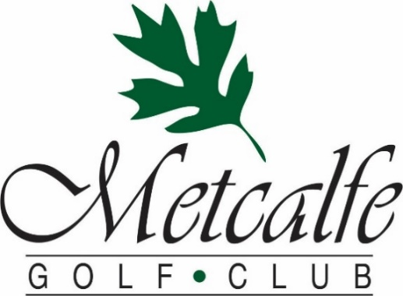

2023 Christmas Menu
The METCALFE GOLF CLUB is home to HICKORIES, a full-service restaurant, which is the perfect venue to host your Christmas Party this season. Hickories offers…
- Superb cuisine including our Famous Roast Beef “au Jus”
- Friendly country service in a relaxed atmosphere
- Experienced Chef that can create a custom menu for your event
- Find out why our clients tell us over and over: “This is the best food we have ever had at a golf course”
Rooms & Capacities
Main Dining Room: 50-60
Fireplace Room: 32
Sunroom (which may be used in combination with the Fireplace Room): 16

Here is What Organizers Say About Events at The Metcalfe Golf Club
“Every member of Metcalfe Golf was very helpful, set up of the private room beautiful, food was delicious and served timely and with smile. Once again THANKS for making it the best tournament ever.”
“Just wanted to express my thanks for making our event an amazing celebration of my husband’s 50th! I received many compliments about the food, service and venue. Everything was perfect. Everyone at the course was helpful, accommodating, and friendly. I couldn’t have asked for anything better!”
We will work with you to ensure that our food, venue, and service create a day that you and your guests will enjoy and remember.
Facility Rental Fees & Inclusions
Facility Rental Fee: $0 (with a minimum of $1500 in pre-booked F&B), $200 (with a minimum of $1000 in pre-booked F&B) or $400 (with under $1000 in pre-booked F&B)
Included With Your Event:
Bartenders, Table Linens

Hickories Christmas Buffet
Fresh Baked Rolls
Crisp Mixed Greens & Fresh Garden Vegetables with an assortment of Dressings
Creamy Broccoli, Bacon & Cheese Salad
Seafood Pasta Salad
Holiday Mashed Potatoes
Steamed Seasonal Vegetables
Penne Pasta in Sun-dried Tomato “Rose” Sauce
Choice of:
Slow-roasted AAA Roast Beef
Marinated in our special blend of spices with Red Wine “au Jus”
or
Roasted Turkey with all the fixings
Fantastic Assorted Dessert Table
Coffee, Tea
$42
Select both Turkey and Roast Beef for an additional $7 p.p.

A Minimum of 25 people are required for a buffet
All Prices Are Per Person - 13% HST & 15% Gratuity are not included

Hickories 3 Course Table Service Meals

Soup or Salad Choice Of:
Mixed Greens & Crisp Vegetables with our House Garlic Dressing
(upgrade to Caesar Salad for $3)
or
Our Chef’s Soup Creation
Entrees Choice Of:
Char-grilled 10oz Alberta AAA Striploin
Herb-Garlic Roasted Potato & Seasonal Vegetables
or
Roasted Red Pepper and Goat Cheese Stuffed Chicken
7oz Stuffed chicken supreme with light cream thyme sauce
Herb-Garlic Roasted Potato & Seasonal Vegetables
or
Hickories Atlantic Salmon Filet
Topped with Creamy White Wine-Dill Sauce
Herb-Garlic Roasted Potato & Seasonal Vegetables
Dessert Choice Of:
Rich Chocolate Fudge Cake with Raspberry Coulis
or
Old Fashioned Carrot Cake with Cream Cheese Icing
or
Decadent Pecan Pie with Maple Caramel Sauce

$46 (Steak Entrée is $52)

Table Service Meals for groups of 15 or more
1 Soup or Salad, 1 Entrée & 1 Dessert must be chosen for the entire group

All Prices Are Per Person - 13% HST & 15% Gratuity are not included
Appetizers & Cocktail Platters
HOT APPETIZERS - (Served by the dozen, minimum 3 dozen)
Sweet and Sour Glazed Meatballs $ 18
Tomato Bruschetta with Greek Feta Cheese $ 18
Lightly Dusted Chicken Wings, Dipping Sauces & Ranch Dip $ 21
Breaded Tiger Shrimp, Sweet chili Thai sauce $ 30
COLD APPETIZERS - (Served by the dozen, minimum 3 dozen)
Whipped Herbed Cream Cheese & Cucumber Rounds $ 18 Multigrain crostini, double cream brie & apple chutney $ 24
Caprese skewers with mini bocconcini, cherry tomatoes and basil $ 24
Smoked salmon pinwheels $ 30

COCKTAIL PLATTERS
(Serves 25 people if added to a meal)
(Additional quantities is recommended if being served without a meal)
Crisp Garden Vegetables, Herb Ranch Dip $ 109
Mixed Canadian Cheeses & Crackers $ 129
Seasonal Fruit Platter $ 129
Assorted Olives, Marinated Vegetables & Pickles $ 59
Charcutier Board with Mixed Deli Meats and Marinated Vegetables $ 149
All Prices Are Per Person - 13% HST & 15% Gratuity are not included
Our Chef can also create a custom menu for your event
To Book your Christmas Party, please contact Rob Howell
rhowell@metcalfegolf.com or 613-821-3673

