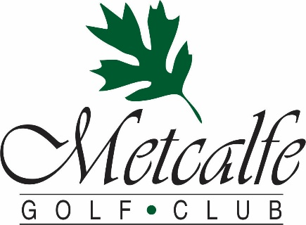
Metcalfe Golf offers a beautiful setting that is perfect for your ceremony, pictures, and reception. Our rental fees and menu are designed to include almost all charges, so you will not incur extra costs for items such as dishes, chairs, cake cutting etc. We will work with you to ensure that our food, venue, and service create a day that you and your guests will remember forever!!!

We offer:
- We offer a beautiful outdoor setting for your ceremony and pictures
- Outdoor banquet tent, on interlock deck, overlooking our 9-hole course’s 1st hole
- Suburb Cuisine
- Friendly country service in a relaxed atmosphere
- Main dining room with adjacent patio shaded by our 400 year old Oak Tree
- Private room with stone fireplace.
- Pre-wedding golf outings
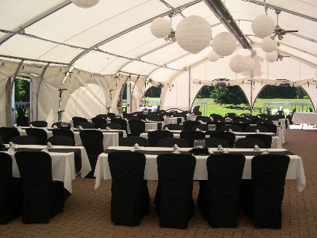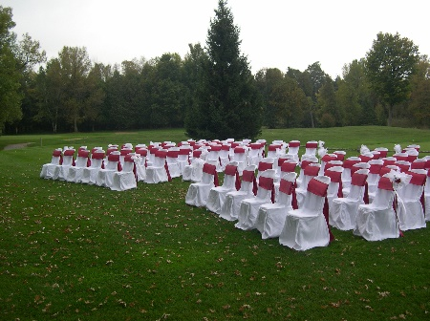

Here Is What Our Wedding Clients Have to Say:

“The Metcalfe Golf Club was the perfect location for our wedding. When planning, they were more than eager to cater to our details and give helpful suggestions. We were married under their beautiful 400 year old Oak Tree giving us great shade on a hot summer day. The tent for our reception equipped with ceiling fans was beautifully decorated and gave a scenic view of the greens. Everyone thoroughly enjoyed their meal and then some. We will definitely be going back!”
- Lori & Claude Bouchard

“We just wanted to say a huge thank you for working with us to put together a beautiful wedding. You were always kind and very helpful. We enjoyed every minute of working with you. The service was fantastic, and all our guests had a wonderful time and only had good things to say about the food and venue! We could not have asked for a better day, and it will remain engraved in our hearts forever. Thanks again for being a part of our wedding day - Jennifer & Simon
To Book an Appointment to Discuss Your Wedding, Wedding Reception, Rehearsal or Golf Outing (613) 821- Fore (3673) or weddings@metcalfegolf.com

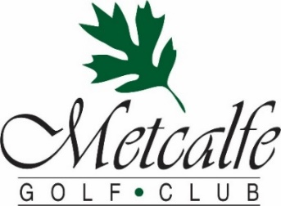
Metcalfe Golf Club – 2024 Wedding Fees
Fireplace Room (up to 30), Main Room (up to 45)
or Patio Rental (capacity 60) $499

Banquet Tent Rental (up to 120 guests) $799

Wedding Service on Site $299

SOCAN FEE (to have music) $44.13 (100 or less) $63.49 (100 or more)
RE SOUND FEE (to have music) $18.51 (100 or less) $26.63 (100 or more)

Metcalfe Golf Club – 2024 Wedding Minimums
The minimum cost to host a wedding is $4000. The minimum price per confirmed guest is $90.00. Rental fees, food and pre-booked beverages count towards the minimum (gratuity and hst are excluded)

The Following Items Are Included in Our Rental Fees:
- Our house tablecloths in a selection of green, burgundy, black, royal blue & white
- White linen napkins
- Our banquet patio tables & bistro chairs
- Our selection of dishes
- Table set up – linens, glasses, silverware, plates, coffee cups & saucers
- Glass flower vases & LED candles in frosted holders
- Pictures on site
- Bartenders
- Cutting of your wedding cake
- Wedding Service on Site includes, Arch, set up of chairs, signing table etc.

The Following Items Are NOT Included in Our Rental Fees:
- Additional quantities or colors of linen or runners
- Additional tables, chairs, or dish rentals

All prices subject to 13% HST

4 Course Table Service Wedding Dinners

All dinners include the choice of one soup, one salad and one dessert. Should you wish to have a 3 course menu you may deduct $7.00. You may offer your guests the choice of two entrees provided numbers are confirmed 7 days ahead and choices are indicated by guest on the seating plan. We are also able to accommodate allergies with 14 advance notice.

All dinners include

Choice Soup
Creamy Potato and Leek
Smoked Tomato and Basil
Broccoli and Aged Cheddar

Choice of Salad
Mesclun Mixed Greens with homemade Garlic Dressing
Caesar Salad with Grana Padano Parmesan and Garlic Crouton
Strawberry Spinach Salad with Raspberry Vinaigrette

Choice of Entrée
Tarragon Chicken $60
Tender Chicken Breast with a fresh tarragon and grainy Dijon cream sauce
Maple Glazed Bacon Chicken Supreme $60
Double smoked Bacon wrapped Chicken Supreme
topped with a sweet garlic maple glaze

Seared Atlantic Salmon $65
Atlantic Salmon topped with Dill-Citrus Hollandaise Sauce

All prices include all four courses and are subject to 15% gratuity and 13% HST

6 ounce Beef Tenderloin $75
Grilled Angus Beef tenderloin
smothered with a red wine shallot demi-glace

Grilled Striploin $75
10 ounce Canadian beef Strip loin topped with burgundy wine sauce

Vegetarian and Vegan $60
Customized dishes served to fit your specific guests

All main Courses include
Choice of Roasted Red Skin Potato, Dauphinois Potatoes,
Roasted Garlic Mashed Potato or Rice Pilaf and served with Fresh Seasonal Vegetable Medley

Choice of Dessert
Chocolate Mousse Cake
Strawberry Rhubarb Crisp
Old Fashion Carrot Cake
Cherry Cheesecake

All prices include all four courses and are subject to 15% gratuity and 13% HST

Wedding Buffet Dinner Selections…
Entrées Choices:
Our Famous Roast Beef “au Jus”
Chicken Breast, Fleur de Dijon, and cracked peppercorn cream sauce
Pork Tenderloin, Port Reduction and Green Peppercorn Sauce
Baked Atlantic Salmon, Citrus-Dill Hollandaise Sauce
Pasta
Penne Noodles in Sundried Tomato “Rose” Sauce
(Included in all Buffets)

Hot Sides
Steamed Seasonal Vegetable Medley
Maple-Butter Glazed Baby Carrots
Mixed Bell Peppers & Green Beans
Smoked Paprika Potatoes Wedges
Roasted Baby Potatoes
Lemon-Thyme Rice Pilaf

Salads
Crisp Greens & Garden Vegetables with an array of Dressings
Pearl Harvest Cous Cous Salad
Pesto-Olive Oil Fusilli Salad
Creamy Potato Salad
Authentic Greek Salad
Traditional Caesar Salad
Citrus Summer Coleslaw
Seafood Pasta Salad
Seasonal Salad Selection

Dessert Choices:
An assortment of Cakes and Pies to satisfy your taste,
served with Tea & Coffee

$50 per person with 1 Entrée, 2 Hot Sides & 3 Cold Sides
Each additional Entrée $6 /person
Each additional Side $3/person
All prices are subject to 15% gratuity and 13% HST

Appetizers & Late Night Snack Options
HOT APPETIZERS
(Served by the dozen, minimum 2 dozen)

Tomato Bruschetta with Greek Feta Cheese $ 18
Sweet and Sour Glazed Meatballs $ 20
Mini Chicken Spring Rolls, Sweet Chili Thai $ 21
Baked Italian Sausage wrapped in Puff Pastry, Maple-Mustard Dip $ 24
Cream Cheese stuffed Jalapeno Poppers $ 24
Breaded Tiger Shrimp, Sweet chili Thai sauce $ 30
Applewood Bacon Wrapped Scallops, Vodka Cocktail Sauce $ 36

COLD APPETIZERS
(Served by the dozen, minimum 2 dozen)

Whipped Herbed Cream Cheese & Cucumber Rounds $ 18
Crostini with onion relish, shaved beef & horseradish crème $ 24
Multigrain crostini, double cream brie & apple chutney $ 24
Caprese skewers with mini bocconcini, cherry tomatoes and basil $ 24
Smoked salmon pinwheels $ 27
Chicken tzatziki flatbread bite $ 27

COCKTAIL PLATTERS
(We can make recommendations on quantities for cocktail hour and/or late-night snack)
SM LRG
Crisp Garden Vegetables, Herb Ranch Dip $55 $95
Mixed Canadian Cheeses & Crackers $70 $125
Sandwich Wedges including Tuna, Salmon, Roast Beef, Egg, Ham… $60 $100
Seasonal Fruit Platter $65 $110
Sliced Cold Cut “Deli” Meats $65 $110
Charcutier Board with Mixed Deli Meats and Marinated Vegetables $90 $155

Additional Late Night Options
(Per person price with minimum 25 people purchased for)

French fries and Sweet potato fry bar $ 9
Loaded poutine bar with St Alberts cheese curds $ 14
Mixed flatbreads including meat, veggie and cheese $ 11

Fruit Punches
Exotic Fruit Punch, $99 serves 50 people
Spiked Fruit Punch, $159 serves 50 people

We will be pleased to recommend the appropriate quantities

All prices are subject to 15% gratuity and 13% HST

Wedding Sample Package #1
Platters & Passed Appetizers during Cocktail Hour/Photographs
Canadian Cheese and Cracker Platter & Fresh Mixed Vegetable Platter with Dill Ranch Dip
Passed Tomato Basil Bruschetta/Sweet and Sour Beef Meatballs/Cream Cheese Cucumber Rounds
Exotic Fruit Punch (Non-alcoholic)
Plated 3 Course Table Service Meal
Your choice of two Proteins Chicken or Fish as entrée dish with a wide selection of hot sides and vegetables includes soup or salad and a selection of decedent dessert options
Late Night Snack
Hickories Fry Bar comes with Fresh French Fries and Sweet Potato Fries
$80 per person (Beef entrée option $10 per person extra)

Wedding Sample Package #2
Passed Appetizers during Cocktail Hour/Photographs
Cream Cheese Stuffed Jalapeno Poppers/Breaded Tiger Shrimp/Italian Sausage wrapped in Puff Pastry/Mini Caprese skewers/Smoked Salmon Pinwheels
Buffet Dinner
Hickories Famous Roast Beef au Jus Buffet & Chicken breast in a Dijon Cream Sauce served with Sundried Tomato Rose Penne with a wide selection of Hot Sides and Signature Salads
Late Night Snack
Loaded Poutine Snack Bar comes with fresh St Alberts cheese curds and assorted toppings
$85 per person

Wedding Sample Package #3
Platter & Passed Appetizers during Cocktail Hour/Photographs
Charcutier Board with mixed Deli Meats and assorted Marinated Vegetables
Bacon Wrapped Scallops/Tomato Basil Bruschetta/Shaved Beef Crostini/Whipped Cream Cheese Cucumber Rounds & Exotic Fruit Punch (alcoholic)
Plated 3 Course Table Service Meal
Your choice of two Proteins Beef/Chicken/Fish entrée dish with a wide selection of hot side and vegetables includes soup or salad and a selection of decedent dessert options
Late Night Snack
Assorted “tea” sandwiches (chicken/tuna/egg/ham/turkey) & Mixed Canadian Cheese Platter & Fresh Vegetable Platter with dill ranch dip
$95 per Person
15% Gratuity and 13% hst are not included in package prices
Wine Options
Metcalfe Golf Club is licensed under the LLBO. We offer three options for wine service at your reception

#1 Our House Wine
Pelee Island Pinot Grigio (White) & Merlot (Red)
If you select our House Wine, you will be charged for the wine which is poured at the cost of $32 per bottle (750ml)

#2 L.C.B.O Wine
You may select any wine carried by the LCBO and we will have it on hand for you. The cost is the LCBO retail price plus $18 per bottle. (Based on a 750ml bottle)

#3 Homemade Wines
As permitted by the alcohol and gaming commission you may serve homemade wine at your reception. You are responsible for obtaining & presenting the special occasions permit & wine to the Metcalfe Golf Club three days before your reception. A maximum of two bottles per table of 8 can be served. If you choose to bring your own wine alcohol, service from our bar will be stopped during your dinner.

A corkage fee of $20 per bottle is charged. (Based on a 750ml bottle)

15% Gratuity and 13% hst are not included.

Other Information
Wedding Cakes (or Cupcakes) are the only food items that may be supplied by you

Recommended Services

DJ - Quality Entertainment 526-8742 www.qualityentertainment.ca
$100 off their regular rate

Live Music – Metcalfe Music Entertainment Rick Smith 821-1195
www.metcalfemusic.com

Wedding Officiants – All Season’s Weddings Kathleen Everett 821-1106
www.allseasonsweddings.com

To Book an Appointment to Discuss Your Wedding, Wedding Reception, Rehearsal or Golf Outing (613) 821- Fore (3673) or weddings@metcalfegolf.com

